Carmel Lions Club – Newsletter
September 2019

BOARD OF DIRECTORS
PRESIDENT | Jason Randlett
1st VICE PRESIDENT | Bill Ryan
(Newsletter, club directory)
2nd VICE PRESIDENT | Christine  Woodward
(K.P. chairperson, kitchen supplies)
3rd VICE PRESIDENT | Jeremiah Scott
(Rentals, maintenance, building supplies, grounds)
SECRETARY | Rick Dossey
TREASURER | Carl Kinker
TAIL TWISTER | John Rodgers
LION TAMER | David DeVilbiss
FIRST YEAR DIRECTORS  SECOND YEAR DIRECTORS  MEMBERSHIP CHAIR  IMMEDIATE PAST PRESIDENT  BOARD OF DIRECTORS’ MEETINGS  Board Meetings First Tuesday, 7:00 PM at the Lions' Clubhouse | Mary Jane Bodnar  Kyle Rich  Tim Fischer  Dwight Gossett  Tom Lorson  Steve Gross

President’s Message
Thoughts from President Jason:
Dear Fellow Lions,
We just finished a September to remember. We had a golf outing that had full field of golfers and raised more money than ever. A huge thanks to Dwight, Alice and Norwin for leading this event. Dwight sent over a Thank You note to the board expressing his thanks to all that helped, and we will circulate that to the club. Dwight and Alice have asked to step back from the event, and Denise Jensen will be taking over going forward. We want to thank Dwight and Alice for all of their work establishing this event and Denise has our full support going forward. I also want to thank all of the members that sponsored, or golfed, or brought sponsors or added golfers. We had two teams tie for first place, and everyone had a great time. Our success is a reflection of your contributions.

Last weekend, the club was spread a little thin as we covered the School for the Blind track meet and the Arts Festival. Thanks to volunteers working long hours and taking on both events, We Served! We took the time this weekend to accomplish two very big goals. First, we created stories of serving. As I worked the Arts Festival tent, I heard stories from the various volunteers that had worked the track meet. They told those stories with such joy and enthusiasm that I could not help but smile. I hope that everyone that worked that event came away with stories they can share. Those stories resonate with people and leave them with a vivid image of what Lions do. Please keep telling those stories. For those that worked the Arts Festival, thank you. Thank you for all that you do to raise money for our causes and thank you for showing people that Lions exist. We had countless customers ask – What do Lions do? We were ready with a smile and an answer. We need to continue to tell our stories, and we need to continue having fun! People want to join a club where the members serve, and have fun doing it. There was no shortage of smiles in the tent this weekend, even with the rain. For all of the Lions that served this weekend at the track event, or the Arts Festival – Thank you.

If you did not have a chance to serve this weekend, don’t worry, the pancake breakfast is coming up!!! Lastly, we are working on a VERY SPECIAL meeting for Oct 22nd. I am hoping to be able to share more details at our meeting on Oct 8th, and I will follow up with an email. PLEASE, mark down Oct 22nd on your calendar, and please plan to join us at the clubhouse.

New member Info:
At the arts festival we met 3 possible new members.
Every time we are out in the public eye, we have an opportunity to add
members to our club.

2019 Activities coming up:

Fall Pancake Breakfast
Oct. 26th

Please get out there and sell tickets.

The golf outing was a ton of fun.

This is this years winning team with a score of -17

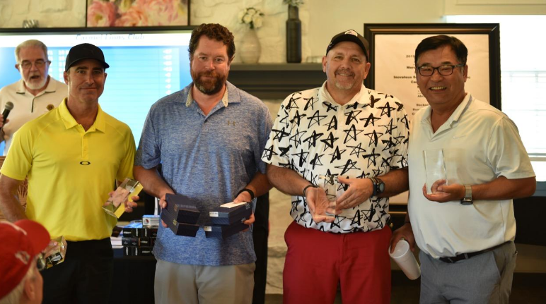

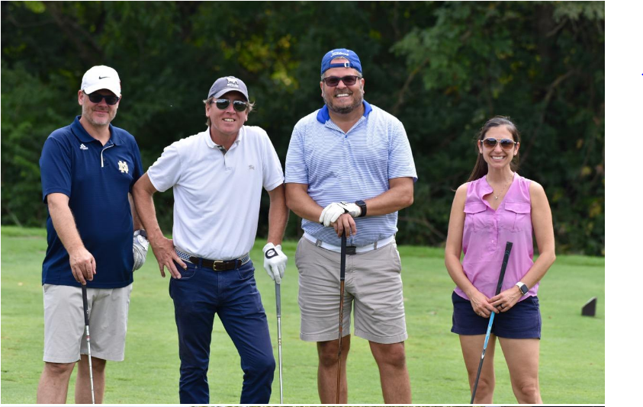

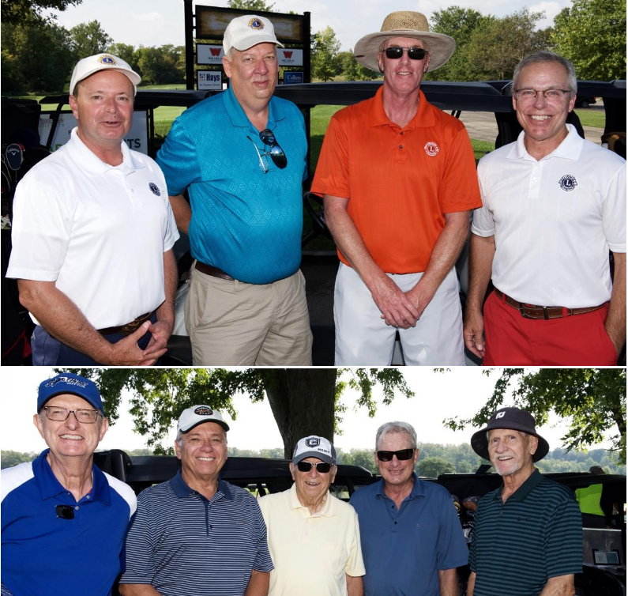

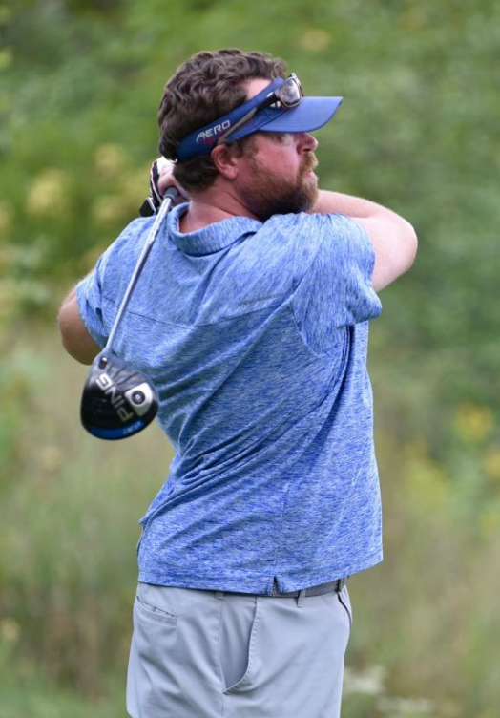

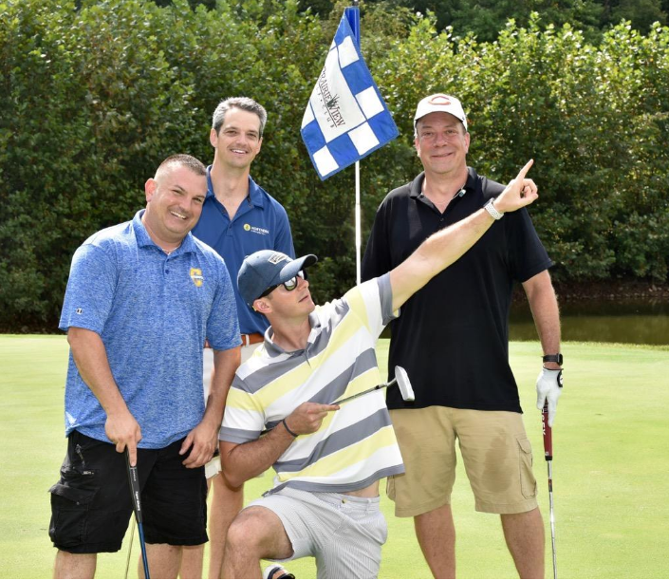

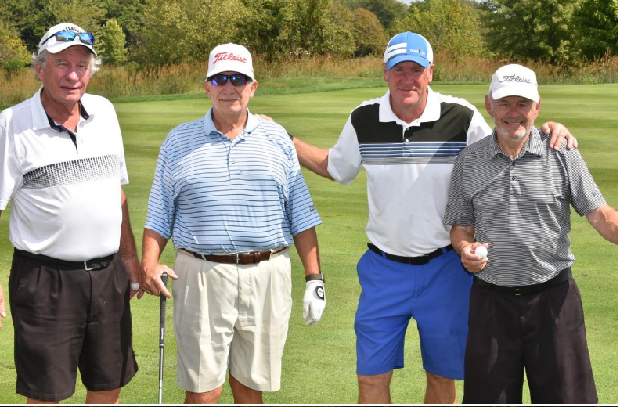

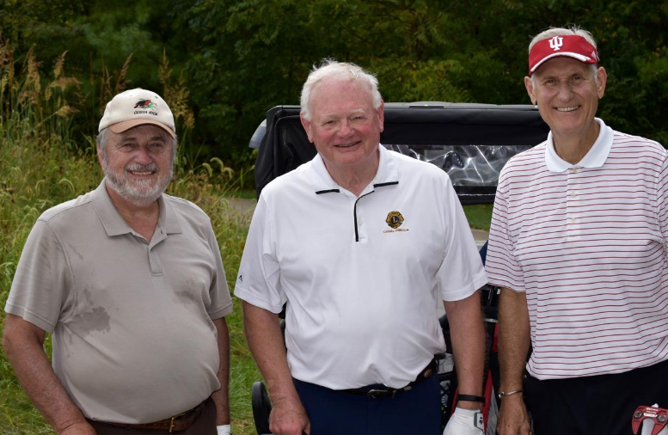

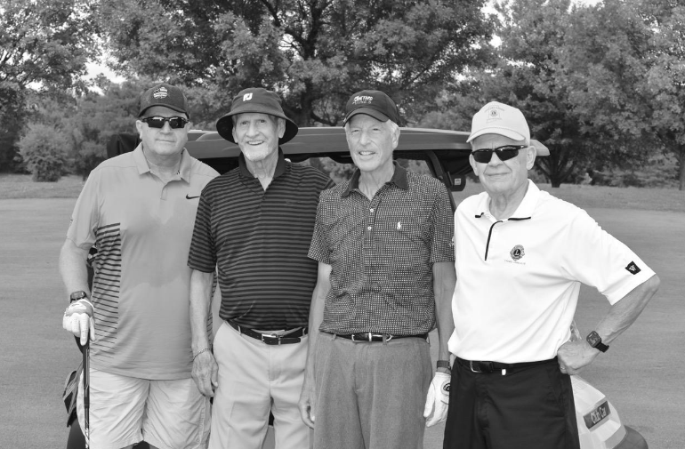

School for the blind track meet picture
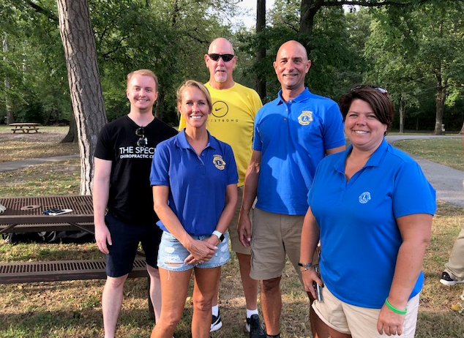

Arts Festival pictures

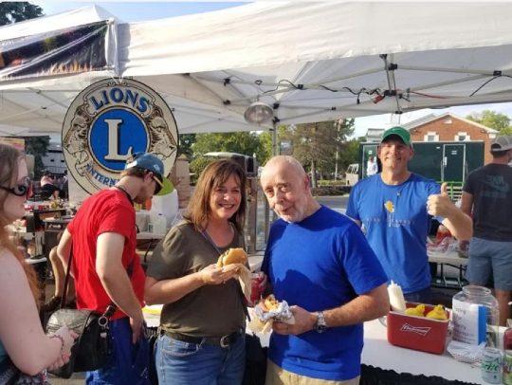
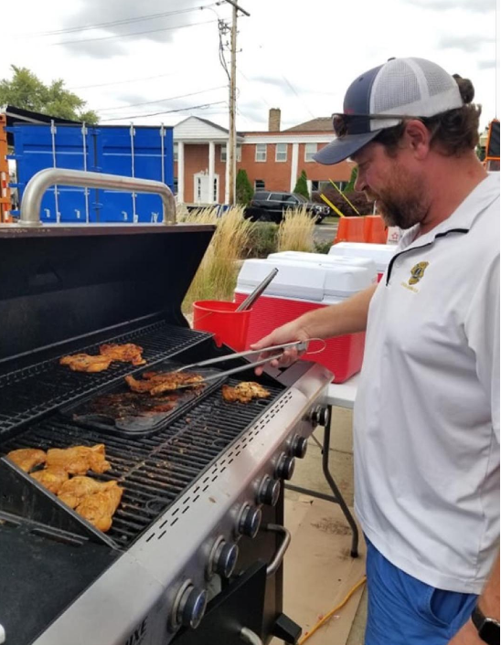

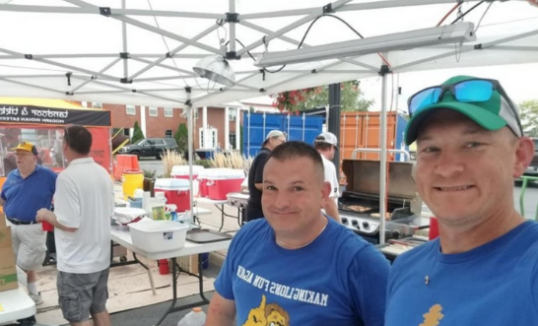

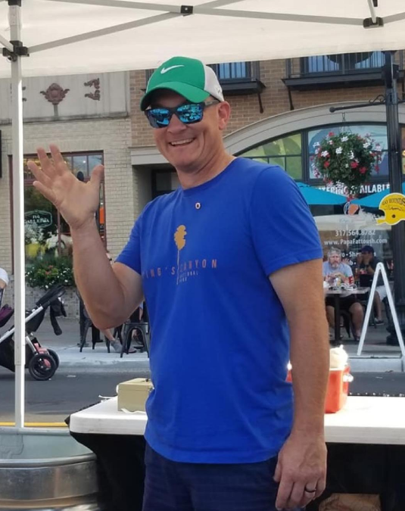

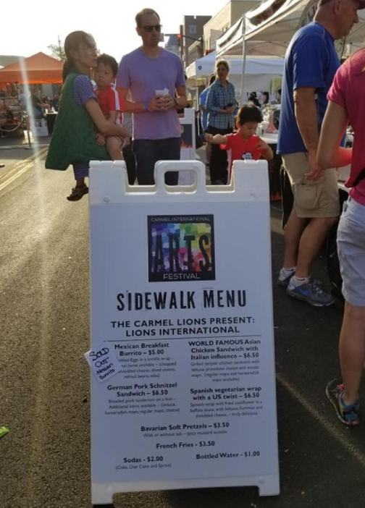
The menu board

World famous chicken sandwich!
“wow” said Claude Wood A.K.A. Dr. BBQ

Meetings:
Next board meeting is on 10/01/19
Kyle Rich will host

Oct. 8
KP’S : Karen Butler and Bob Kraft

Oct. 22
KP’S : Tim Fischer, Alison Burkhard , and Glenn Simpkins

Thanks to all of the Lions that helped at the golf outing and the arts fest.

Carmel Lions Club Board Meeting Minutes September 2019

10 board members present, one on the phone

Summary of August Electronic Board Meetings

During August, two electronic board meetings were held, approving the membership applications of Linda & Claude Wood, John Jensen, and Venkata Aditya.

September Board Meeting:

On 9/17/19, the regular Board Meeting commenced at 7:11 – Tom Lorson brought snacks.

In attendance were Jason Randlett, Kyle Rich, Steve Gross, Carl Kinker, Mary Jane Bodnar, Bill Ryan, Tom Lorson, David DeVilbiss, Dwight Gossett, Rick Dossey; Christine Woodward called in and participated via speakerphone.

Dictionary Project: Four elementary schools have applied for $300 grants to purchase books for their media centers, in lieu of receiving dictionaries for their 3rd graders. Those schools were Cherry Tree, Woodbrook, Smokey Row, and Mohawk Trails. Tom Lorson made a motion to accept the grant requests, Bill Ryan seconded, and the board approved. Bill will coordinate purchase and labelling of the books.

Financial Report: Carl Kinker presented the financial report. Tom Lorson made a motion to spend $300 again this year on the Ghost & Goblins run, Steve Gross seconded, and the board approved. Jason Randlett expressed interest in winnowing down the list of recipients for our donations, so we would be making a larger impact with each recipient. Going forward, those leading fundraising projects would be given priority in nominating charitable causes towards which the proceeds went.

New Member: Tom recounted the recent growth in newer and younger members – several have expressed interest in joining the past weeks, including three at the golf outing.

Commercial Property Appraisal: The appraisal has been completed, and a meeting with the CRC has been held. The summary of the situation is this: Our property is currently zoned as residential, and as such, will not yield its full potential value in a sale. A buyer offering top dollar for our property would have to have assurance that the city would rezone the property as commercial. Consequently, our options in selling the property are constrained by the city’s willingness to approve/partner with such a buyer. Realistically, we will be in the current clubhouse for at least 2-3 more years.

Golf Outing: The outing netted close to $11,000 – making it the most profitable fund raiser of the year. The board was grateful for the work that Alice & Dwight Gossett, along with Norwin Hall, put in to make it a success. Several other Lions made key contributions – they will be recognized at the next regular meeting.

Pancake Breakfast: Woody will be quoting on providing sausage for the upcoming breakfast.

Building Maintenance: The Boy Scouts left the front door to the building open after their meeting this week, Tim Fischer will speak to them about this.

Our insurance company gave us $21,238 for roof damage and repairs – Aaron Mueller will be quoting on repair work, which needs to be done before winter.

The air conditioner in the board room needs replacing by spring – this should cost about $4,000. Jeremiah will coordinate.

Bill Ryan has received a contract to switch our cleaning service to JCOS, the monthly cost is the same as what we are currently paying, but the annual stripping and polishing of the floor should cost less. Bill made a motion to switch services, Steve Gross seconded, and the board approved, with Dwight dissenting.

The Fish Fry sign still needs to be taken down, and the American flag needs to be replaced.

Republic will be contacted to see if lower trash removal rates can be obtained, as we are zoned residential.

Fish Fry: We are still negotiating with McFarling about the return of unused food items – our total profit should be about $10k on this event.

Technology: Bill Ryan will trial wireless microphones during upcoming regular meetings; he will also examine alternatives for on-line file/picture sharing.

Wellness Committee: Bill Ryan will put together and lead a wellness committee.
International Arts Festival: Several Lions will be serving food on September 28 & 29 in downtown Carmel. As the base of food suppliers has shrunk, we should be busy and raise money for our charities. We are gaining good visibility at these events, in addition to new members –

Tom Lorson and lions were recognized for work at canvas on carmel.
(thank you Tom)

The meeting concluded at 8:39.

Future meetings:

The next board meeting is on October 1st, 2019

